NEW REQUIREMENTS OF ONLINE REGISTRATION PROCESS
Version 1.1

ADMINISTRATOR ROLE :

Three new Menus in the Administrator Role User

→ Transfer of Customers To Service Center
→ Generate AMC Due Report
→ Update AMC Collection Details

- Transfer Of Customer To Service Center
This page is used to transfer the customer from one service center to another.
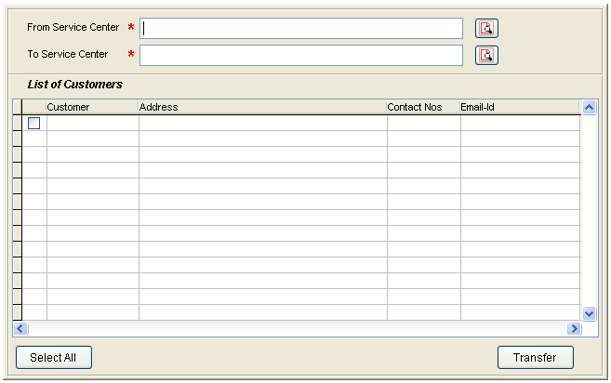

- Generate AMC Due Report
  - This page is used to generate AMC due report, by default all the service centers data for next one month will be displayed.
  - Individual Partners can be selected & also date range whose AMC’s are due between that range.

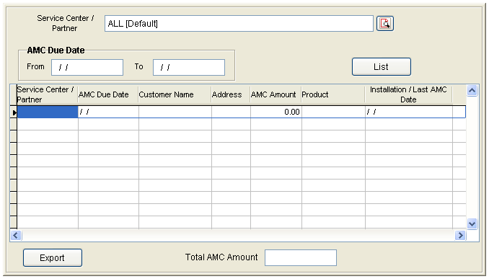

- Update AMC Collections
This needs to be discussed with Mr. Arun & Mr. Komar for further clarification

PARTNERS ROLE :

In Partners Login New Menu Page to be opened instead of the List of Customers under them. Following are the menu list items to be displayed.

→ Order Confirmation
→ Update Registration Information
→ Re-Send Registration License & Register.me.
→ Generate AMC Reminder [Report & Letter]
→ Generate AMC Confirmation Letters [AMC Entries]

- Order Confirmation Page :-
Add two new fields to enter ‘User Name’ and ‘Password’ for the customer which should be maintained in another table and to be used for customer Login. Also ‘MAC Id’ to be stored similar to application server Ip address.

- Update Registration Information :-
The page will be same as Order Confirmation, but allow to update all the fields only if Register.me is not generated.

- Generate / Re-send Registration License :-
This Page will allow to select the customer of that particular partner only. After customer selection display the data information similar to the Order confirmation page [non-editable]. This generate or re-send registration license [Register.me] file to the customer.

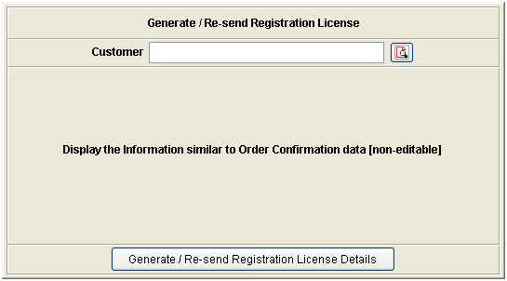

- Generate AMC Reminder [Report & Letter] :-
  - This page will display the list of customers to generate AMC reminder letters whose AMC due date is in the date range selected.

  - ‘Generate Reminders’ button will generate the reminder letters [Preformatted] for the selected records.

  - ‘Export’ button will generate the report of the same data displayed in the required format [Excel, Word, Pdf, Html]

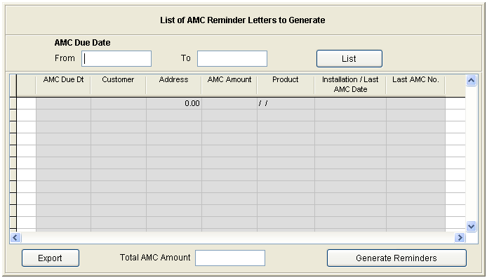

- Generate AMC Renewed Letters [AMC Entries] :-
  - This page is used to make the AMC entries of the customers and generate the AMC renewed letters.

  - Display list of customers whose AMC renewed is pending for generation depending on the date range selected.

  - Fields to be entered : AMC from date, AMC to date, Udyog AMC Amount, Partner AMC Amount.

  - ‘Generate AMC Renewed Letters’ button will generate the AMC renewed Letters [Preformatted] for the selected customers and send it to them.

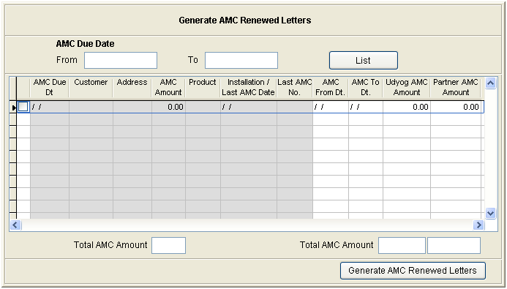

CUSTOMERS ROLE :
This is very new i.e., a new login page will be required for the customer to login. The login data entered in the order confirmation page by the partner is to be used.

Following are the menus to be displayed after customer login.
- Update My Profile
- Download License Certificate & Registration File.
- AMC Status.
- About New Products & Releases

- Update My Profile :-

  - Display the same page of order confirmation page, but allow only the following details to update :-
Installation address details, Billing address details, also allow to add ‘MAC Id’ [New field entry for application servers only].

  - Keep a check box for New registration which will be used as approval for generating new register.me file.

  - If data is updated for already generated Register.me ask if new register.me to be generated or not.

- Download License Certificate & Register.me file :-
Download License Certificate & register.me from the data already generated.

- Registration Status :-
This page is used to display the current status of the customers registration.